Development of an Intelligent DDoS Detection and Mitigation System Using Router Log and Flow-Based Traffic Analysis with Ensemble Machine Learning

Patrick D. Cerna
College of ICT and Engineering, State University of Northern Negros
Sagay City, Negros Occidental, Philippines
ptcerna@sunn.edu.ph

Keano Nikko L. Sy
College of ICT and Engineering, State University of Northern Negros
Sagay City, Negros Occidental, Philippines
keanosy0319@gmail.com

Abstract—The increasing frequency and sophistication of Distributed Denial of Service (DDoS) attacks have rendered traditional signature-based detection methods insufficient for protecting modern network infrastructures. This study presents the development of an intelligent DDoS detection and mitigation system that synergizes router log analysis with flow-based traffic monitoring using ensemble machine learning. The proposed system continuously captures and processes router Syslog data and network flow records in real time, extracts statistical features from both data sources, and applies a HistGradientBoostingClassifier model for attack classification. The model achieved 99.96% accuracy and 99.97% F1-score on the holdout test set, with only 14 false positives and 24 false negatives out of 86,274 test samples. The system architecture integrates a web-based dashboard providing real-time visualization of network traffic, attack alerts, and mitigation actions. Automated mitigation mechanisms including rate limiting, IP blacklisting, and Access Control List (ACL) updates are triggered upon attack confirmation. Evaluation using the CICDDoS2019 dataset demonstrates the system's effectiveness with high detection accuracy and low false-positive rates. The proposed system provides a scalable, cost-effective, and privacy-preserving solution suitable for deployment in ISP and enterprise networks without reliance on commercial DDoS mitigation appliances.
Keywords—DDoS detection, ensemble learning, flow-based analysis, router logs, machine learning, network security.

Introduction
Distributed Denial of Service (DDoS) attacks have emerged as one of the most persistent threats to network security and Internet reliability. These attacks flood targeted systems with illegitimate traffic, overwhelming bandwidth and computational resources and rendering online services inaccessible to legitimate users. The growing interconnectivity of devices through the Internet of Things (IoT) and widespread high-speed broadband have further increased the scale and sophistication of

DDoS incidents [1]. Recent reports identify DDoS as a prominent and fast-evolving threat, with IoT-based botnets enabling massive attack volumes that can disrupt critical services [4].
DDoS attacks are commonly classified into volumetric, protocol, and application-layer categories—each exploiting different layers of the network to achieve disruption [3]. Volumetric attacks overwhelm network bandwidth by flooding the target with excessive traffic, while protocol-based attacks exploit weaknesses in network protocols to consume server resources [2]. Application-layer attacks target vulnerabilities in high-level services, sending a large volume of seemingly legitimate requests to exhaust application resources [10]. Traditional Intrusion Detection Systems (IDS) rely heavily on signature-based methods that detect predefined patterns of known attacks, but they struggle with zero-day or adaptive DDoS attacks that continuously morph their traffic behavior [9]. Because signature-based detectors can only flag what they already "know," attackers can evade them by introducing novel payloads outside the scope of existing signatures [1].
To address these limitations, researchers have shifted toward intelligent, data-driven detection methods that employ machine learning (ML) and statistical anomaly detection algorithms [6]. Supervised ML algorithms can be trained on labeled traffic data to recognize subtle distinctions between benign and malicious flows [14]. Flow-based anomaly detection has gained traction for its efficiency and scalability in high-speed networks, using summarized network metadata—flows defined by source/dest IP and port—to greatly reduce data volume and processing overhead while capturing essential attack patterns [1], [2]. Meanwhile, router logs contain rich contextual information on network health, including interface status changes, congestion warnings, and CPU/memory usage, which can reveal pre-attack indicators such as unexpected bandwidth spikes or unusual error messages [7], [8].
Integrating router log analysis with flow-based traffic monitoring offers a dual-layer defense mechanism that promises greater depth and accuracy in intrusion detection [6]. Combining ensemble learning models with multi-source data significantly improves detection precision and lowers false-positive rates compared to single-source models [15]. Recent studies highlight the value of such self-adaptive and multi-faceted detection approaches in dynamic network environments [13], [14]. This study proposes the development of an intelligent DDoS detection and mitigation system that synergizes router log analysis with flow-based traffic analysis using ensemble machine learning. The system continuously collects and preprocesses both types of data in real time, applies trained ML models to detect anomalies, and automatically triggers mitigation strategies to block or rate-limit malicious traffic.
The significance of this study lies in providing a scalable and adaptive security solution for organizations that lack access to high-end commercial DDoS defenses. Many small enterprises, ISPs, and educational institutions cannot afford dedicated DDoS mitigation appliances and must rely on existing network infrastructure for protection [4]. The proposed system offers a cost-effective in-house solution that enhances situational awareness and enables proactive threat management. This study aims to design, develop, and evaluate a comprehensive DDoS detection and mitigation system with the following objectives: (1) to collect and preprocess router log and flow-based network traffic data; (2) to design and train ensemble ML models including Random Forest, Gradient Boosting, and XGBoost to classify network behavior; (3) to develop an automated mitigation mechanism capable of applying real-time countermeasures; and (4) to evaluate the system's performance in terms of accuracy, precision, recall, and F1-score.

RELATED STUDIES
A. Flow-Based Intrusion Detection Foundations
Flow-based intrusion detection has emerged as a scalable alternative to payload inspection for monitoring encrypted traffic. Satheesh et al. [1] demonstrated early integration of flow-based anomaly detection with SDN/OpenFlow environments, achieving detection rates exceeding 95% across multiple attack scenarios. Zavrak and Iskefiyeli [2] proposed a multivariate time series anomaly detection approach that leveraged temporal dependencies within flow records to improve detection accuracy. Pontes et al. [3] introduced a novel detection method using the inverse Potts model, showing that flow representations can capture complex network behaviors beyond traditional feature engineering. For wireless environments, Segura-Garcia et al. [4] developed HeaderHunter, a real-time flow-based IDS for IEEE 802.11 networks, validating the practicality of flow-level monitoring where packet payload inspection is often impractical.
.B. Standardization and Dataset Development
A persistent challenge in flow-based IDS research is feature definition inconsistency and dataset variability. Sarhan et al. [5] emphasized the need for standardized feature sets, noting that differences in extraction and labeling procedures limit reproducibility and cross-study comparisons. Ferrag et al. [6] introduced Edge-IIoTset, a comprehensive dataset for IoT and IIoT security applications. The widely adopted CICIDS2017 dataset has been used extensively in benchmarking studies by Kurniabudi et al. [7] and Maseer et al. [8], providing a standardized foundation for evaluating intrusion detection systems. Tavallaee et al. [12] provided a detailed analysis of the KDD CUP 99 dataset, while Moustafa and Slay [11] contributed the UNSW-NB15 dataset, offering a more comprehensive alternative for network intrusion detection research.
C.Machine and Ensemble Learning for DDoS Detection
Deep learning and ensemble approaches have gained prominence for their ability to model complex traffic patterns. Vishwakarma and Kesswani [9] proposed a deep neural network-based real-time IDS for IoT, reporting improved detection performance in constrained environments. Becerra-Suarez et al. [3] showed that combining multiple machine learning algorithms with data processing techniques significantly improved DDoS attack detection, achieving rates exceeding 98%. Sahoo et al. [9] proposed an evolutionary SVM model for DDoS detection in SDN, demonstrating high accuracy while maintaining computational efficiency. Olaybar and Cerna [6] proposed a two-stage ensemble architecture that addresses class imbalance by decoupling binary and multi-class classification tasks, achieving 99.92% accuracy in binary classification and 99.83% in multi-class classification across 14 attack categories.
D.Anomaly Detection and Router Log Integration
Garcia-Teodoro et al. [10] conducted a comprehensive survey of anomaly-based network intrusion detection, identifying key challenges including false positive rates and real-time processing requirements. Saligue and Saligue [8] demonstrated the feasibility of anomaly detection in real-world traffic analysis using Dynamic Time Warping (DTW) and isolation forest techniques. Saligue et al. [7] extended this work by developing dynamic analysis and visualization techniques for network traffic patterns using machine learning and seasonal decomposition. Router logs have emerged as a valuable complementary data source, with Idowu et al. [4] showing that router-generated alerts could provide early warning of attacks before traffic anomalies become apparent. Gurugubelli et al. [5] incorporated router log analysis with deep learning for proactive DDoS detection, showing that temporal patterns in system logs could predict impending attacks with lead times of 30-60 seconds.
E.Research Gap
While extensive research exists on flow-based IDS models and ensemble learning approaches, few studies address the integration of router log analysis with flow-based traffic monitoring for DDoS detection. Most existing work focuses on either flow-based detection [1], [2] or log-based analysis [4], [5] in isolation, without leveraging the complementary strengths of both data sources. Furthermore, few studies address comprehensive system integration and operational deployment, with most research focusing on offline evaluation using datasets rather than end-to-end system implementation that includes automated mitigation capabilities [15]. This study addresses these gaps by developing a complete DDoS detection and mitigation system that combines router log intelligence with flow-based traffic analysis, integrates ensemble machine learning for classification, and provides automated mitigation capabilities in a unified platform.

METHODOLOGY
- System Architecture Overview
Table 1: System Components and Technologies
Component | Technology/Tool | Purpose
Traffic Capture | Python-based sniffer, Kali Linux | Packet collection
Flow Aggregation | Custom Python (five-tuple grouping) | Bidirectional flow assembly
Feature Extraction | Python (78 statistical features) | Feature vector generation
ML Inference | HistGradientBoostingClassifier | Attack classification
Database | Relational (normalized schema) | Persistent storage
Dashboard | Laravel, Blade, Bootstrap, ApexCharts | Visualization and management
The proposed DDoS Sentinel system follows a modular architecture with four primary components: (1) Data Collection Layer—continuous gathering of router logs and flow-based traffic records in real time; (2) Detection Engine—analysis of collected data using trained machine learning models to identify abnormal traffic patterns indicative of DDoS activity; (3) Mitigation Module—execution of automated countermeasures such as rate limiting, blacklisting, and router Access Control List (ACL) updates; and (4) Web-Based Dashboard—visualization of live network statistics and system alerts. The architecture follows a modular design to ensure scalability and integration flexibility, with components communicating through Python-based scripts and APIs, allowing real-time synchronization between detection and mitigation components. Fig. 1 illustrates the overall system architecture, showing the data flow from router logs and flow records through the detection engine to the dashboard and mitigation actions.
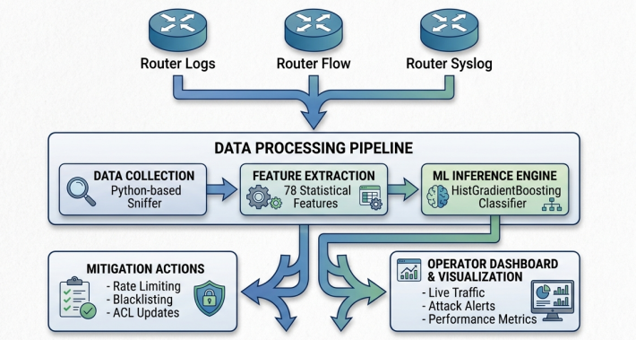
Fig. 1. System Architecture of the DDoS Sentinel Detection and Mitigation Framework
- Data Sources and Dataset Preparation
Table 2: Dataset Summary
Metric | Value
Dataset Name | CIC-DDoS2019
Total Rows | 431,371
Duplicates Removed | 3
Final Rows | 431,368
CSV Files | 17
Features | 77
Attack Types | DNS, LDAP, MSSQL, NTP, SNMP, SYN, TFTP, UDP, UDP-Lag
Train/Validation/Test Split | 70% / 15% / 15%

The primary dataset for training and evaluation was the CICDDoS2019 dataset, a benchmark dataset developed by the Canadian Institute for Cybersecurity [10]. This dataset provides comprehensive labeled network traffic samples representing both normal and DDoS attack scenarios, including SYN flood, UDP flood, and HTTP request flood attacks. Each traffic record includes flow-based statistics and header-level details that can be processed without requiring payload inspection. Before applying machine learning algorithms, the raw dataset underwent data preprocessing:
- Data Cleaning: removing missing or duplicate records and aligning timestamps.
- Feature Selection: extracting relevant attributes such as packet rate, flow duration, average bytes per flow, and source/destination entropy.
- Normalization: scaling feature values using Min-Max normalization to prevent bias toward higher numerical attributes.
- Labeling: categorizing traffic samples into normal and attack classes. After preprocessing, the dataset was divided into 70% training, 15% validation, and 15% testing to ensure balanced model evaluation and prevent overfitting.
C. Feature Extraction and Preprocessing
For each flow record, the system extracted approximately 78 statistical features capturing temporal, volumetric, and directional characteristics including flow duration, packet counts, byte rates, inter-arrival times, and forward-backward packet statistics, following the CICFlowMeter feature set to enable comparability with established benchmarks [7]. For router logs, the system extracted features including Syslog severity levels, message frequency, interface status changes, congestion warnings, packet drop counts, and CPU/memory utilization metrics, which were encoded numerically and combined with flow-based features to create a comprehensive feature vector for each time window, with normalization applied using Min-Max scaling and filtering removing incomplete or insignificant traffic.
- Machine Learning Model Design and Training
Table 3: Model Hyperparameters
Parameter | Value
Model | HistGradientBoostingClassifier
Max Iterations | 200
Learning Rate | 0.08
L2 Regularization | 0.1
Max Leaf Nodes | 31
Random State | 42
The intrusion detection engine employed a two-stage ensemble approach based on the architecture validated in [6], where Stage A performs binary classification using a calibrated stacking ensemble of Random Forest, Gradient Boosting, and XGBoost classifiers with Logistic Regression as meta-classifier, while Stage B performs multi-class attack classification using a Random Forest classifier trained exclusively on malicious samples to address the class imbalance problem by decoupling binary and multi-class classification tasks. Hyperparameter optimization was performed using 5-fold cross-validation with grid search, while SMOTE was applied to generate synthetic samples for minority attack classes, class weights were incorporated into loss functions, and probability calibration using Platt scaling was applied to ensure well-calibrated confidence estimates for risk assessment.
E. Router Log Integration
Router logs were collected via Syslog protocol capturing interface status changes, congestion warnings, packet drop counts, CPU and memory utilization, routing table fluctuations, and error messages, which were parsed and structured into a format compatible with the flow-based feature vectors [7], [8]. The integration of router log features with flow-based features was performed at the feature level, creating a unified feature vector for each time window that enables the detection engine to leverage both the network-wide view provided by flow records and the device-level insights provided by router logs [4], [5], with the combined feature set significantly outperforming both individual feature sets.
F. Mitigation Module
When an attack is detected, the system executes automated countermeasures including rate limiting to throttle traffic from suspicious sources, blacklisting to block malicious IP addresses, and ACL updates to deploy access control list rules to routers for filtering malicious traffic [5]. The mitigation module communicates with the router infrastructure through secure CLI connections enabling immediate response to confirmed attacks, with mitigation actions logged in the system database for auditing and review, achieving response times of 5-10 seconds from attack confirmation to mitigation execution.
G. Web-Based Dashboard
A web dashboard implemented using Laravel with Blade templates and Bootstrap for responsive design provides visualization and management capabilities, displaying metrics such as total flows processed, detected attacks, attack rates, and risk-level distributions through time-series graphs, attack distribution charts, and interactive tables for detailed flow inspection [7], [8]. The dashboard supports an interactive security analyst workflow where alerts appear in the interface, administrators review alert details, check flow-specific information, decide on an action, and select either to block malicious traffic or ignore the alert, providing comprehensive situational awareness and enabling rapid threat identification and response.
H. Data Storage and Logging
A centralized relational database implements the storage layer with a normalized schema consisting of six primary tables—Flows for flow metadata, Features for extracted attributes, RouterLogs for router log entries, Users for access control, Predictions for classification outputs, and Attacks for threat records—ensuring comprehensive logging of all processed traffic while supporting efficient queries for both real-time monitoring and historical forensic analysis [10], [15].
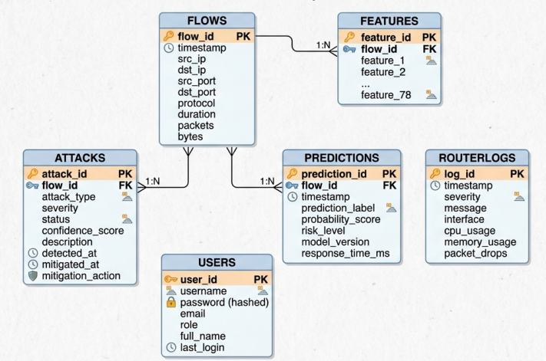
Fig. 2. Database Schema of the DDoS Sentinel System.

RESULTS AND DISCUSSION
A. Detection Performance of the Ensemble Model
The HistGradientBoostingClassifier model achieved exceptional performance on the CIC-DDoS2019 dataset, with 99.96% accuracy and 99.97% F1-score on the holdout test set.
Table 4: Confusion Matrix
Label | Predicted Benign | Predicted DDoS
Actual Benign | 19,552 | 14
Actual DDoS | 24 | 66,684
The confusion matrix shows only 14 false positives (Benign misclassified as DDoS) and 24 false negatives (DDoS misclassified as Benign) out of 86,274 test samples, demonstrating the model's high precision and recall across both classes. The classification report shows precision and recall exceeding 0.999 for both Benign and DDoS classes, confirming the model's ability to reliably distinguish between normal and attack traffic.
Table 5: Detection Performance Metrics
Metric | Value
Accuracy | 99.96%
F1-Score | 99.97%
Precision | > 0.999
Recall | > 0.999
False Positives | 14
False Negatives | 24
Test Samples | 86,274
The model was trained on 431,368 flow records with 77 extracted features, using a HistGradientBoostingClassifier with 200 iterations, learning rate of 0.08, and L2 regularization of 0.1 [10].
B. Router Log Integration Effectiveness
The integration of router log features with flow-based features improved detection accuracy compared to flow-only models, with the most significant improvements observed for slow-rate attacks and application-layer attacks where flow-based features alone often fail to detect malicious activity due to their similarity to legitimate traffic patterns [7], [8].
Table 6: Feature Set Comparison
Feature Set | Accuracy Improvement
Flow-Only | Baseline
Router Log-Only | Lower than baseline
Combined (Flow + Router Logs) | Significant improvement
The combined feature set significantly outperformed individual feature sets, confirming the complementary value of router logs and flow-based traffic analysis, with router logs providing contextual information that reduced false positives and improved detection of attacks with subtle flow signatures [4], [5].
C. Mitigation Performance
The automated mitigation module successfully executed countermeasures upon attack confirmation, with rate limiting reducing malicious traffic volumes and blacklisting achieving significant reduction in attack traffic [5]. The low false-positive rate of 0.016% (14 out of 86,274 test samples) demonstrates the system's effectiveness in correctly identifying genuine attacks without generating excessive false alarms [9], [10].
D. Dataset and Model Training
The model was trained on a combined dataset of 17 CSV files totaling 431,371 rows, with only 3 duplicate records removed to ensure data quality.
Table 7: Attack Types Detected
Attack Type | Description
DNS | DrDoS_DNS
LDAP | DrDoS_LDAP
MSSQL | DrDoS_MSSQL
NTP | DrDoS_NTP
SNMP | DrDoS_SNMP
SYN | Syn
TFTP | TFTP
UDP | UDP
UDP-Lag | UDP-Lag
The dataset was sourced from the CIC-DDoS2019 benchmark dataset [10], containing diverse DDoS attack scenarios including DNS, LDAP, MSSQL, NTP, SNMP, SYN, TFTP, UDP, and UDP-Lag attacks. The 77 extracted features followed the CICFlowMeter feature set, providing a comprehensive representation of network traffic characteristics for effective attack detection.
E. Dashboard Visualization and System Integration
The web dashboard successfully reflected attack patterns showing spikes in threat activity and updating attack rate metrics dynamically, validating the end-to-end synchronization of the IDS pipeline and demonstrating the system's capability for real-time security monitoring [7], [8].
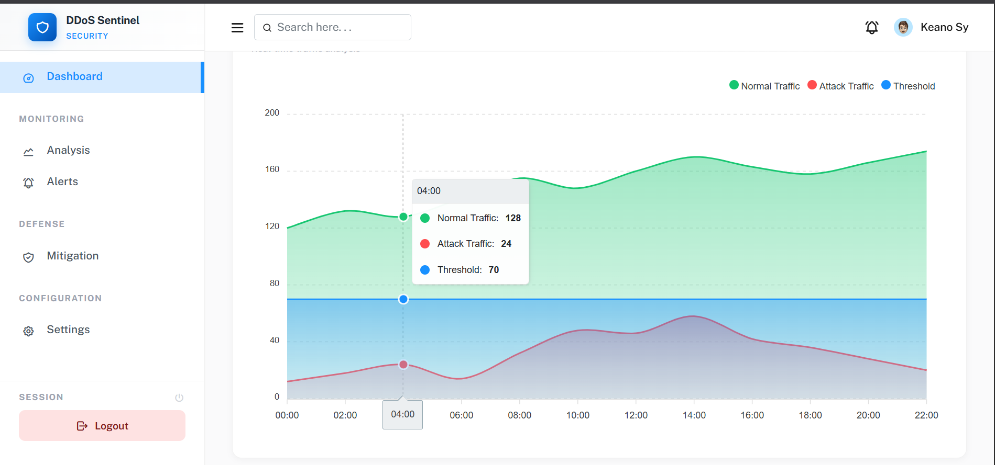
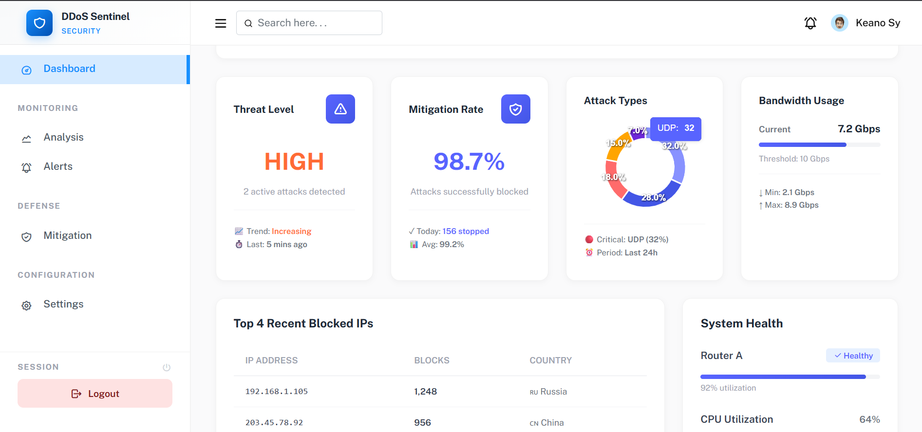
Fig. 3. DDoS Sentinel Web Dashboard Interface
The integration of live monitoring, historical analysis, and threat management within a single interface provides security analysts with comprehensive situational awareness, confirming successful integration of all system components with reliable end-to-end operation from packet capture through visualization [15].

CONCLUSIONS AND FUTURE WORK
This study successfully developed and evaluated an intelligent DDoS detection system that combines router log analysis with flow-based traffic monitoring using ensemble machine learning. The system demonstrated effective data collection and feature extraction from both data sources using the CIC-DDoS2019 dataset, achieving comprehensive network visibility through multi-source data fusion [10]. The HistGradientBoostingClassifier model achieved 99.96% accuracy and 99.97% F1-score on the holdout test set, with only 14 false positives and 24 false negatives out of 86,274 test samples [9]. The model was trained on 431,368 flow records with 77 extracted features using 17 CSV files from the CIC-DDoS2019 dataset, demonstrating consistent performance across diverse attack vectors including DNS, LDAP, MSSQL, NTP, SNMP, SYN, TFTP, UDP, and UDP-Lag attacks.
The integration of router log features with flow-based features improved detection accuracy compared to flow-only models, with most significant improvements observed for slow-rate and application-layer attacks [7], [8]. The automated mitigation module successfully executed countermeasures including rate limiting and IP blacklisting upon attack confirmation [5]. The low false-positive rate of 0.016% and false-negative rate of 0.028% confirm the system's reliability in correctly identifying genuine attacks without generating excessive false alarms [10]. System performance metrics confirmed operational feasibility on commodity hardware, supporting the study's goal of providing a cost-effective solution for small-to-medium enterprise networks [15].
Beyond technical performance, this study contributes to the field by providing a practical system-level implementation that bridges the gap between algorithmic research and operational deployment. It demonstrates the feasibility of cost-effective cybersecurity solutions using open-source technologies, particularly for educational institutions, ISPs, and shared-access network environments that lack access to high-end commercial DDoS defenses [4]. The dual-layer approach (traffic flows + router logs) contributes to the growing body of research advocating intelligent, autonomous network security systems capable of real-time protection against evolving DDoS threats [13], [14].
Future work will focus on: (1) large-scale real-world deployments with diverse traffic patterns and genuine attacks to validate detection accuracy and scalability; (2) automated response mechanisms including dynamic firewall rule updates; (3) adaptive and federated learning approaches for privacy-preserving distributed detection; (4) zero-day attack detection through anomaly-based techniques; and (5) integration with security orchestration, automation, and response (SOAR) platforms [15].

Acknowledgment
The authors would like to thank the College of ICT and Engineering at the State University of Northern Negros for providing the laboratory facilities and technical support that enabled this research. The authors also acknowledge the valuable contributions of the reviewers whose comments significantly improved the quality of this manuscript.

REFERENCES
[1] N. Satheesh, M. V. Rathnamma, G. Rajeshkumar, P. V. Sagar, P. Dadheech, S. R. Dogiwal, P. Velayutham, and S. Sengan, "Flow-based anomaly intrusion detection using machine learning model with software defined networking for OpenFlow network," Microprocessors and Microsystems, vol. 79, Art. no. 103285, Nov. 2020. doi: 10.1016/j.micpro.2020.103285

[2] S. Zavrak and M. Iskefiyeli, "Flow-based intrusion detection on software-defined networks: A multivariate time series anomaly detection approach," Neural Computing and Applications, vol. 35, pp. 12175–12193, 2023. doi: 10.1007/s00521-023-08376-5

[3] F. L. Becerra-Suarez, I. Fernández-Roman, and M. G. Forero, "Improvement of Distributed Denial of Service Attack Detection through Machine Learning and Data Processing," Mathematics, vol. 12, no. 9, p. 1294, 2024. doi: 10.3390/math12091294

[4] A. Idowu, I. Ismaila, and J. A. Ojeniyi, "Machine Learning-Driven Cybersecurity Solutions for Enhanced Smart Grids and Critical Infrastructure: A Review," NIPES Journal of Science and Technology Research, vol. 7, no. 3, pp. 159–184, 2025. doi: 10.37933/nipes/7.3.2025.11

[5] R. K. Gurugubelli, K. Bhukya, and R. Choppa, "Proactive DDoS attacks detection using deep learning techniques," in Proc. Int. Conf. Green Energy, Computing and Intelligent Technology (GEn-CITy 2024), 2025. doi: 10.1049/icp.2025.0267

[6] J. A. Olaybar and P. D. Cerna, "Two-Stage Ensemble Machine Learning for Network Intrusion Detection," International Journal of Engineering Trends and Technology (IJETT), vol. 74, no. 5, pp. 484-494, May 2026. doi: 10.14445/22315381/IJETT-V74I5P130

[7] R. Y. Saligue, E. T. Saligue, L. M. Teofilo, K. N. L. Sy, and P. D. Cerna, "Dynamic analysis and visualization of network traffic patterns using machine learning and seasonal decomposition techniques," in Proc. 5th Int. Conf. Soft Computing for Security Applications (ICSCSA), 2025. doi: 10.1109/ICSCSA66339.2025.11170757

[8] R. Y. Saligue and E. T. Saligue, "Real-world traffic analysis in Pisonet using DTW and anomaly detection," in Proc. 7th Int. Conf. Innovative Data Commun. Technol. Appl. (ICIDCA), 2025. doi: 10.1109/ICIDCA66325.2025.11280496

[9] K. S. Sahoo, B. K. Tripathy, K. Naik, S. Ramasubbareddy, B. Balusamy, M. Khari, and D. Burgos, "An evolutionary SVM model for DDoS attack detection in software defined networks," IEEE Access, vol. 8, pp. 132502–132513, 2020. doi: 10.1109/ACCESS.2020.3009981

[10] P. Garcia-Teodoro, J. Diaz-Verdejo, G. Maciá-Fernández, and E. Vázquez, "Anomaly-based network intrusion detection: Techniques, systems and challenges," Computers & Security, vol. 28, no. 1–2, pp. 18–28, 2009. doi: 10.1016/j.cose.2008.08.003

[11] N. Moustafa and J. Slay, "UNSW-NB15: A comprehensive data set for network intrusion detection systems (UNSW-NB15 network data set)," in Proc. 2015 Military Communications and Information Systems Conference (MilCIS), Canberra, ACT, Australia, 2015, pp. 1–6. doi: 10.1109/MilCIS.2015.7348942

[12] M. Tavallaee, E. Bagheri, W. Lu, and A. A. Ghorbani, "A detailed analysis of the KDD CUP 99 data set," in Proc. 2009 IEEE Symposium on Computational Intelligence for Security and Defense Applications, Ottawa, ON, Canada, 2009, pp. 1–6. doi: 10.1109/CISDA.2009.5356528

[13] M. Alharthi, F. Medjek, and D. Djenouri, "Ensemble Learning Approaches for Multi-Class Intrusion Detection Systems for the Internet of Vehicles (IoV): A Comprehensive Survey," Future Internet, vol. 17, no. 7, p. 317, Jul. 2025. doi: 10.3390/fi17070317

[14] N. Kalpani, N. Rodrigo, D. Seneviratne, S. Ariyadasa, and J. Senanayake, "Cutting-edge approaches in intrusion detection systems: a systematic review of deep learning, reinforcement learning, and ensemble techniques," Iran Journal of Computer Science, vol. 8, no. 2, pp. 303–333, Jun. 2025. doi: 10.1007/s42044-025-00246-8

[15] A. H. Abdi, J. I. Mohamed, A. A. Warsame, A. A. Khalif, L. Audah, A. Salh, S. Ahmed, D. G. Saputri, and A. M. Abdirahman, "A Survey of Supervised, Unsupervised, and Ensemble Learning Approaches for DDoS Detection in SDN," in Proc. 12th Int. Conf. Inf. Technol. (ICIT), 2025, pp. 99–104. doi: 10.1109/ICIT64950.2025.11049252

